Wireless Network Planning Coverage Analysis in a 3D Urban Outdoor Environment using Ray-Tracing Propagation Model

Simu Calin

Emanuel TRINC

*Abstract*—This electronic document is a “live” template and already defines the components of your paper [title, text, heads, etc.] in its style sheet. *\*CRITICAL: Do Not Use Symbols, Special Characters, Footnotes, or Math in Paper Title or Abstract*. (*Abstract*)

Keywords — Ray Tracing, Wireless Propagation Model

# Introduction

Ray Tracing is probably the most realistic propagation model widely used in Wireless Communications for generating realistic RF channel data. Ray-Tracing simulations in Outdoor 3D environments provide critical insights for deploying and optimizing wireless networks, ensuring reliable and efficient communication services.

The purpose of this paper is to …

In order to perform the simulation for the Ray Tracing in a 3D Urban environment, an RT-based simulator like Simulink MatLab could be used. But, besides the RT simulation tool, there are other considerations as well, like the following:

* Wireless Cell Type
* Cell Layout Type
* Cell Sectorization Type
* Antenna Type
* Frequency Range
* Cell Power Consumption

**Cell Sectorization Type**. TODO

| Cell Sectorization Type | |
| --- | --- |
| Cell Type | Description |
| Macrocell |  |
| Microcell |  |
| Picocell |  |
| Femtocell |  |

**Antenna Type**. TODO

**Cell Shapes**. In wireless cellular networks, hexagonal shaped cells are artificial and cannot be implemented in practice. However this shape is chosen to simplify planning and design of a cellular system, as hexagons fit together without any overlap.

|  | Cell Layout Type | |
| --- | --- | --- |
| Shape | Description |
|  | Hexagonal  *(Fictious)* | Cellular System Planning and Design Simplification |
|  | Circular  *(Ideal)* | Ideal Power Coverage Area |
|  | Irregular  *(Real)* | Shape constant changing due to prevailing conditions. |

# Related Work

There are not that many 3D simulations of this type with RT for dense urban areas with complex building structures as far as we were able to investigate at the point in time this paper was written.

# Simulation Environment Setup

The simulation environment is based on Simulink MatLab with Antenna Toolbox installed, so that we will be able to display transmitter/receiver sites, and RF propagation visualizations using Site Viewer window with 3D Globe.

## A. Site Viewer with Customized 3D Buildings

Site Viewer can be customized with 3D buildings and unique building materials as reported by OpenStreetMap. The building materials will be colored as follows:

“brick” ⟼ "#AA4A44"

“concrete” ⟼ "#D3D3D3"

“copper” ⟼ "#B87333"

“glass” ⟼ "#35707E"

“metal” ⟼ "#151513"

“plaster” ⟼ "#FFFFFF"

“stone” ⟼ "#301934"

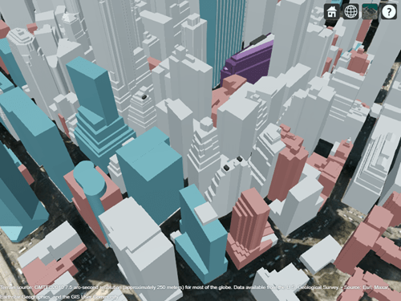

(Fig. 3.1)

## B. Circular Receiver Site Array

As we have seen in the introductory section of this paper, in a real-world scenario, the Wireless Cell Layout is close to a Circular Layout, so for the purposes of this Real-World 3D simulation, we will setup Circular Receiver Arrays at the border of the Wireless Cell so that we can measure various parameters at the border of the planned cell, in order to make the best decision about the best cell radius based on the desired capabilities needed.

These Circular Receiver Arrays can be configured to contain any desired amount of receiver sites, MatLab algorithm will divide equally the provided number of cells in such a way to fit the ${360}^{°}$ of the circle in equal slices and placing each receiver at exactly the same distance from the Transmitter site, which sits in the center of the Cell.

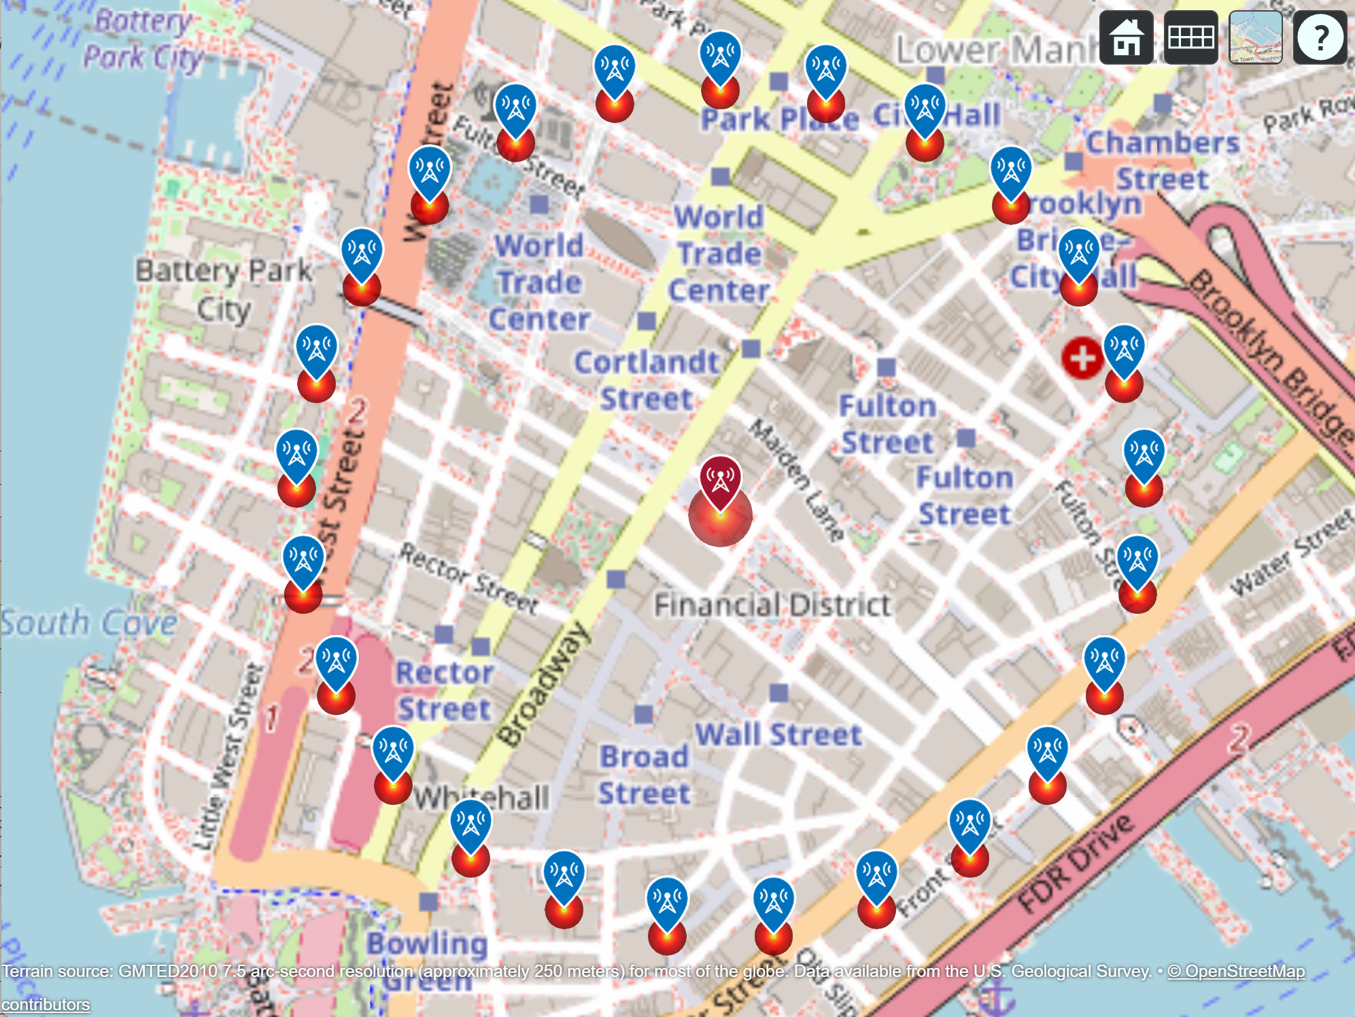

*(Fig. 3.2) 500m radius 25 site Circular Receiver Array in the center of Manhattan*

The 25 site Circular Receiver Array presented in Fig. 3.1 can be overlayed on top of 3D buildings layer, but in this case we will have some of the receivers on top of high buildings which could influence the analysis result in a good or bad way, we just have to be aware of this fact. There is a configuration built-in into the MatLab algorithm that can filter the receivers that are above a certain altitude, if we want to simulate only using ground receivers.

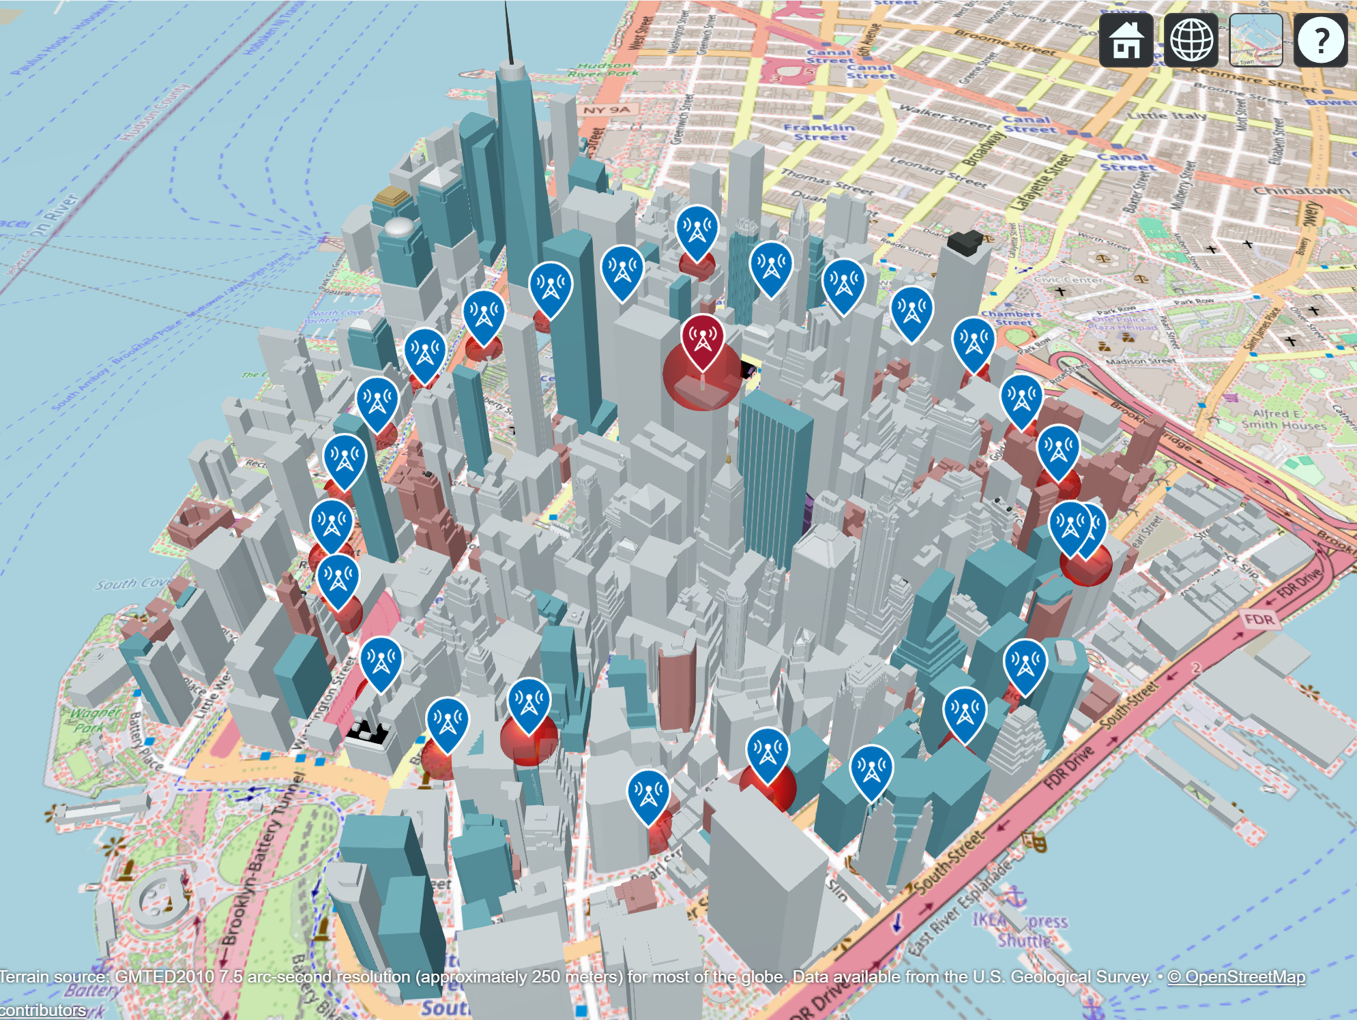

*(Fig. 3.3) 500m radius 25 site Circular Receiver Array overlayed on top of 3D buildings*

# Simulation Results

In this section we will analyze the simulation results for various types of Antennas with different cell sectorization for a 3D urban environment.

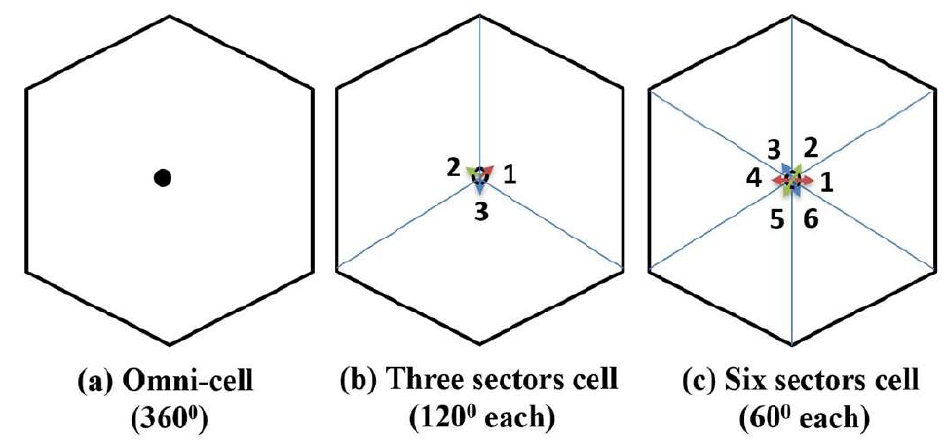

*(Fig. 4.1) Cell Sectorization Types*

## B. LTE Cell with Dipole Antenna @ 2600MHz

VoLTE (Voice over Long-term Evolution) is a technology that allows high-definition (HD) voice communication over 4G LTE networks. Moreover, the connection between 2 terminals is realized faster during a call because VoLTE can use a higher bandwidth.

The purpose of the simulation of VoLTE is to make a Microcell RF Coverage Analysis for a 3D urban environment using Ray-Tracing propagation model. We will start with analyzing what would be the best Cell radius given the cell parameters. To achieve this, a Transmitter site is placed in the middle of the cell and 4 Cell radiuses are considered.

| Simulation Parameter | Parameter Value(s) |
| --- | --- |
| Tx Frequency | 2600 MHz |
| Tx Antenna | Dipole |
| Tx Power | 10W |
| Tx Location | $${40.708619}^{°}N, {-74.010000}^{°}W$$ |
| Tx Antenna Height | 15m |
| Rx Sensitivity | -90 dBm |
| Rx Antenna | Dipole |
| Rx Array Size | 25 sites |
| Cell Radius | 300m, 400m, 500m, 600m |

*(Table 4.1) VoLTE Simulation Parameters*

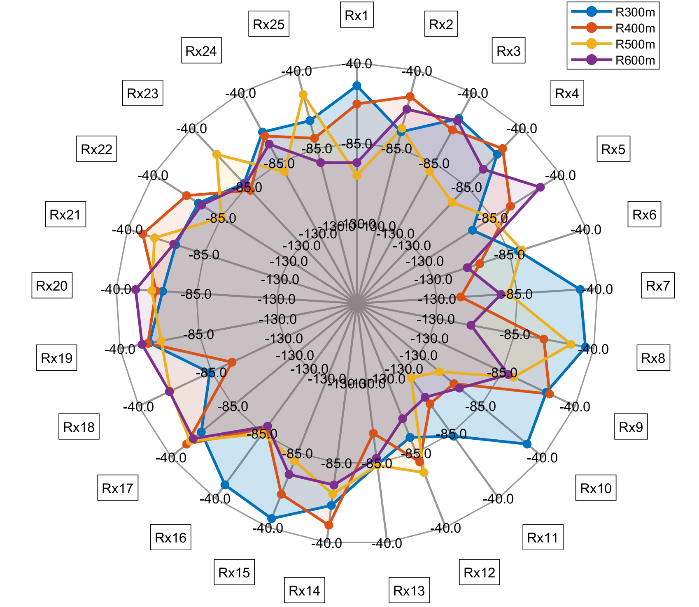

*(Fig. 4.2) Spider plot of 25 site Receiver Array signal strength of the 4 runs (numbers represent dBm)*

The simulation was run 4 times, one time for each Cell Radius and the receiver signal strength results were overlayed in a spider plot for better coverage analysis in order to identify which cell radius would fit best for the given parameters.

Analyzing closely the coverage map obtained in Fig. 4.2, we can observe that for 300m radius we have the biggest area, progressively decreasing for 400m, 500m, and 600m.

The next step would be to choose which Cell radius would fit the best given the frequency and power, and do a further analysis to see more details inside the cell.

Going further we will consider the chosen Cell radius to be 500m. We can then proceed to run the Ray-Tracing analysis using the configuration as shown in the table 4.2.

| Simulation Parameter | Parameter Value(s) |
| --- | --- |
| Cell Radius | 500m |
| RT Method | SBR |
| RT MaxNumReflections | 1 |
| RT MaxNumDiffractions | 1 |

*(Table 4.2) VoLTE 500m Cell Simulation Parameters*

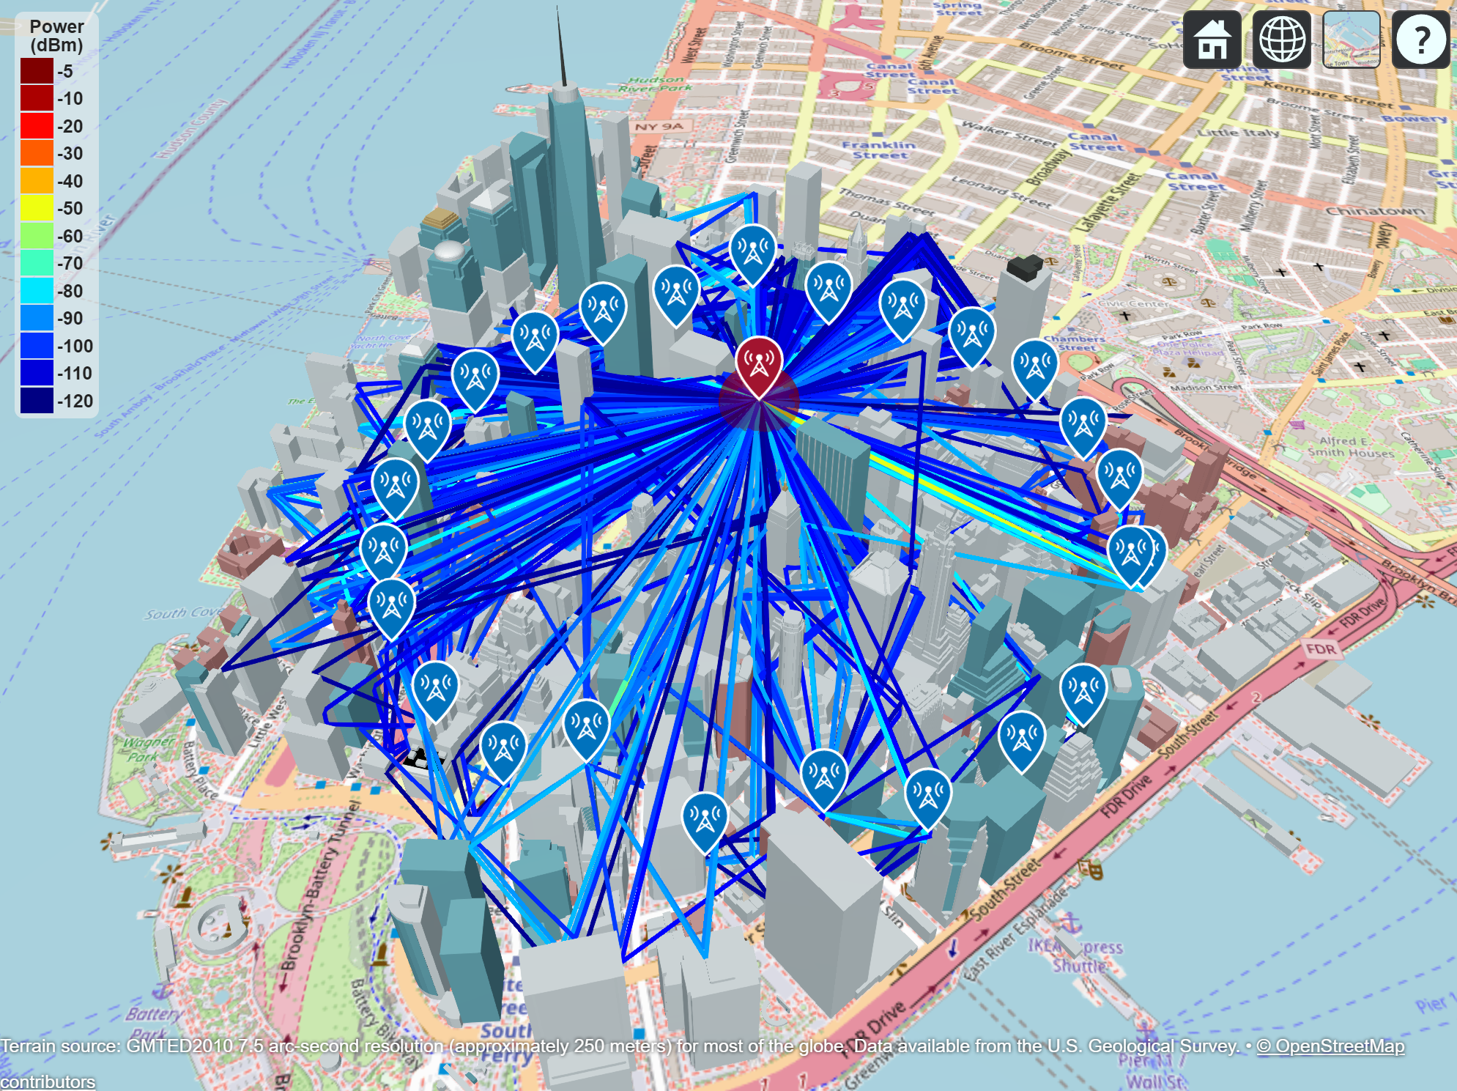

*(Fig. 4.3) RT for 500m radius Circular Receiver Array Layout*

| Rx | Table Column Head | | |
| --- | --- | --- | --- |
| Ray-Tracing [dBm] | RT+Rain [dBm] | Delta [dBm] |
| location pin icon. location pin sign. blue location pin symbol. Map pointer  Icon. 7388581 Vector Art at Vecteezy Rx1 | -123.39 | -123.42 | 1.5 |
| location pin icon. location pin sign. blue location pin symbol. Map pointer  Icon. 7388581 Vector Art at Vecteezy Rx2 | -73.54 | -73.55 | 1.3 |
| location pin icon. location pin sign. blue location pin symbol. Map pointer  Icon. 7388581 Vector Art at Vecteezy Rx3 | -90.41 | -90.42 | 1.2 |
| location pin icon. location pin sign. blue location pin symbol. Map pointer  Icon. 7388581 Vector Art at Vecteezy Rx… | … | … | … |
| location pin icon. location pin sign. blue location pin symbol. Map pointer  Icon. 7388581 Vector Art at Vecteezy Rx24 | -90.69 | -90.70 |  |
| location pin icon. location pin sign. blue location pin symbol. Map pointer  Icon. 7388581 Vector Art at Vecteezy Rx25 | -53.54 | -53.95 |  |

So far we were analyzing what happens at the border of the cell so that we can identify the best cell radius for the given cell parameters, but what if we want to see what is happening with the signal strength inside the cell?

In order to do this analysis we have several ways to approach the problem. One way would be to fill-in the cell with a lot of receivers, simulating pedestrians with mobile units (cell phones), or to use the coverage map calculation and visualization provided by MatLab.

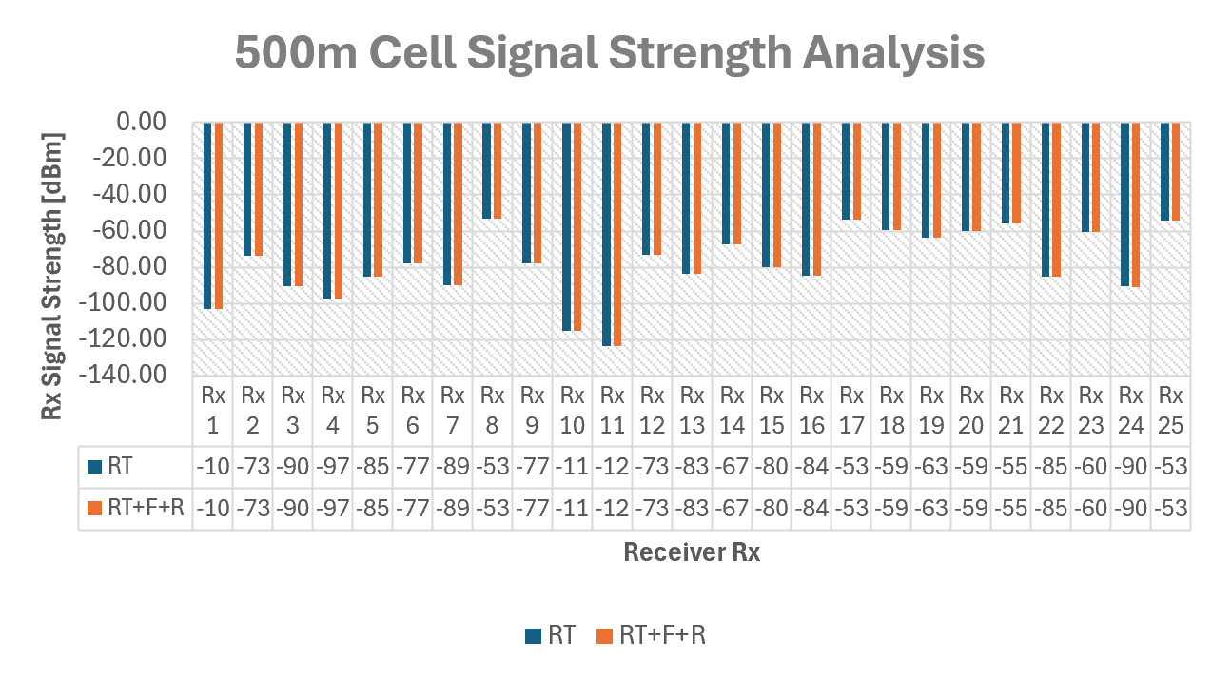

*(Fig. 4.4) 500m Cell Signal Strength Analysis*

## B. Process with Machine Learning

In the previous section we analyzed the signal strength received at the border of the cell with an array of circular receiver sites placed directly on the border of the cell. But what if we want to analyze what is happening inside the cell? More specifically, we want to analyze the signal strength in more detail of all the users residing in every location inside the cell.

There are probably several ways to do that, but the most modern and straightforward way to do it is to place receivers 5-10 meters apart in every ground location inside the cell and analyze the signal strength in detail. But in a 500m radius cell it means we will have to place thousands of receiver sites and process huge amount of data. Luckily, we can generate that amount of data with MatLab, save it in CSV files for later processing with Machine Learning algorithms.

So, the first step is to create a MatLab script to gather all this data from the simulation and save it to a CSV file. But we have to first identify/define what data we want to collect. In ML we need to collect some features and outcomes for each receiver site, and table below presents in more detail the kind of features and outcomes that we can collect for later analysis.

| FEATURES | |
| --- | --- |
| **RF Cell Features** | |
| Cell Sectorization Type | Omni-cell_360deg, Three-sectors_120deg, Six-sectors_60deg, Nine-sectors_30deg, etc |
| Cell Radius [m] | Positive integer |
| **Tx Features** | |
| Tx Power [W] | Positive integer |
| Tx Frequency [Hz] | Positive integer |
| Tx Antenna | Omni-Directional, Directional, etc |
| Tx Antenna Height [m] | Positive integer |
| Tx Antenna Angle [º] | Real number |
| Tx System Loss [dBm] | Real number |
| Tx Coordinate System | Cartesian, |
| **Rx Features** | |
| Rx Sensitivity [dBm] | Real number |
| Rx Antenna | Omni-Directional, Directional, etc |
| Rx Antenna Height [m] | Positive integer |
| Rx Antenna Angle [º] | Real number |
| Rx System Loss [dBm] | Real number |
| **Signal Features** | |
| Propagation Model | RT_SBR, RT_IMG, FREESPACE, LONGLEY-RICE, COMBINED, etc |
| Reflections | Positive integer |
| Diffractions | Positive integer |
| **Geographical Features** | |
| Latitude [ºN] | Real number |
| Longitude [ºW] | Real number |
| Elevation [m] | Real number |
| **Environmental Features** | |
| **Gas Features** (1 – 1000GHz) | |
| Temperature [ºC] | Real number (Air temperature) |
| Air Pressure [Pa] | Real number (Dry air pressure) |
| Water Density [g/ $m^{3}$] | Real number (water vapor density) |
| **Fog/Clouds Features** (10 – 1000GHz) | |
| Temperature [ºC] | Real number (Air temperature) |
| Water Density [g/ $m^{3}$] | Real number (liquid vapor density) |
| **Rain Features** (1 – 1000GHz) | |
| Rain Rate [mm/h] | Real number (precipitation) |
| Tilt [º] | Real number (polarization tilt sig. angle) |
| **OUTCOMES/TARGETS** | |
| Receiver Outcomes | |
| Signal Strength [dBm] | Real number (<= RxSensitivity) |
| Path Loss [dBm] | Real number |

After defining the features and outcomes table, we have to implement the MatLab algorithm to setup the simulation environment and collect all this data.

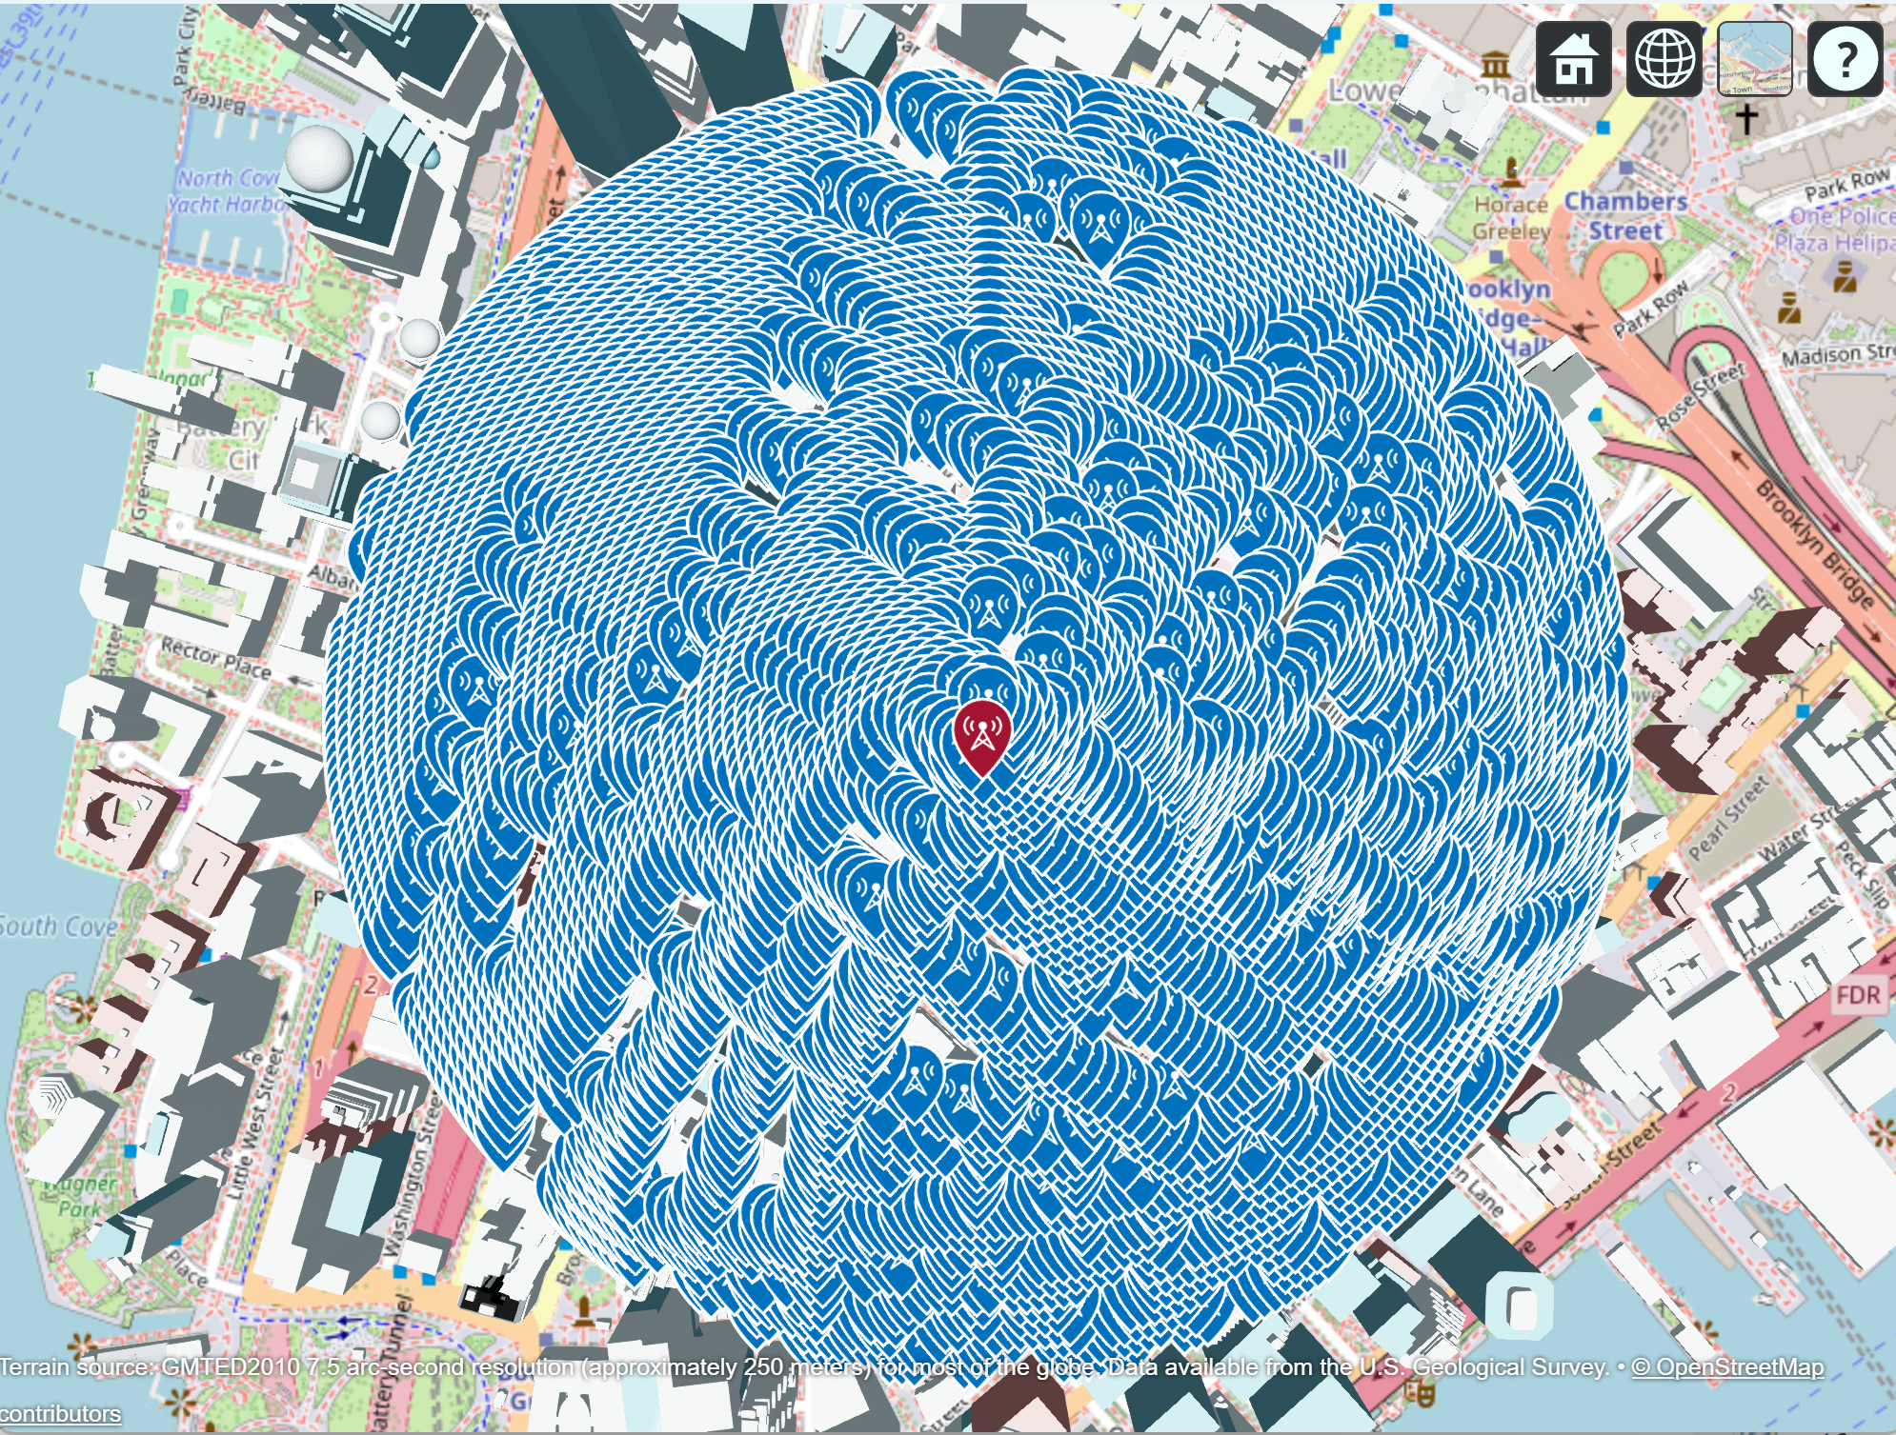*(Fig. 4.4) 8006 Receivers 10m apart generated inside 500m radius Cell at ground level (35m max altitude)*

##### Acknowledgment *(Heading 5)*

The preferred spelling of the word “acknowledgment” in America is without an “e” after the “g”. Avoid the stilted expression “one of us (R. B. G.) thanks ...”. Instead, try “R. B. G. thanks...”. Put sponsor acknowledgments in the unnumbered footnote on the first page.

##### References

1. Z. Liu, P. Zhao, Three-Dimensional Ray-Tracing-Based Propagation Prediction Model for Microcellular Environment at Sub-6 GHz Frequencies, 2024, [link](https://www.mdpi.com/2079-9292/13/8/1451).
2. F. Fuschini, E. M. Vitucci, Ray Tracing Propagation modeling for future small-cell and indoor applications: A review of current techniques, University of Bologna, Italy, 2015 , [link](https://agupubs.onlinelibrary.wiley.com/doi/epdf/10.1002/2015RS005659).
3. S. Hussain, C. Brennan, An efficient ray tracing method for propagation prediction along a mobile route in urban environments, [link](https://agupubs.onlinelibrary.wiley.com/doi/epdf/10.1002/2017RS006275).
4. T. K. Geok, F. Hossain, A Comprehensive Review of Efficient Ray-Tracing Techniques for Wireless Communication, 2018, [link](https://www.researchgate.net/publication/325914256_A_Comprehensive_Review_of_Efficient_Ray-Tracing_Techniques_for_Wireless_Communication).
5. <https://dl.acm.org/doi/10.1145/3479242.3487318>
6. <https://arxiv.org/pdf/2303.11103.pdf>
7. MatLab raytrace(), <https://fr.mathworks.com/help/antenna/ref/txsite.raytrace.html>
8. Urban Link and Coverage Analysis using Ray Tracing, MatLab, <https://fr.mathworks.com/help/comm/ug/urban-channel-link-analysis-and-visualization-using-ray-tracing.html>
9. <https://www.telecomhall.net/t/what-is-the-difference-of-macro-micro-and-picocells-in-wireless-telecommunications/25555>

TODO – Machine Learning Analysis